

**Equality And Diversity Policy**

15 April 20245

Review April 2026

# Policy Statement

Cambridge Online Tuition (“*the Company*”) does not tolerate discrimination or harassment in any part of its operations. This equality and diversity policy sets the Company’s commitment to creating an inclusive environment for everyone who works within and accesses the organization. The Company is committed to encouraging equality and diversity among our wider workforce and eliminating unlawful discrimination.

Recognizing and embracing difference leads to improvements for all. Whilst the Company is fully committed to compliance with all relevant equality legislation (including the equality act 2010, codes of practice, and best practice guidance), this policy builds on the statutory position to ensure effective policies and practice that promote equality and inclusion.

This policy covers any and all aspects of the Company’s operations, how it treats those who work for and with it, and how it recruits or engages others to join that community.

This means that our policy covers, but is not limited to, the following:-

* 1. Pay and your self-employment conditions;
  2. Recruitment processes;
  3. How the Company may appraise, reward, incentivise, promote, train, and commit to the continuing professional development of its workers;
  4. Procedures for addressing grievances and disciplinary matters; and
  5. The policy for ending self-employment contracts and exit subcontractors.

It also means that the Company will ensure, as far as possible:

1. Full access to everyone applying for job vacancies and job opportunities within the Company; and
2. That all relevant decisions are made on the basis of objective criteria.

You should familiarise yourself with this policy and all Cambridge Online Tuition’s other policies.

# Who does This Policy apply to?

All self-employed subcontractors of any type.

# Is this policy part of my employment contract?

This policy is not part of your employment contract. Cambridge Online Tuition, may amend this policy at any time.

# What is discrimination?

Under UK employment law, there is a set of individual characteristics that must not unfairly be considered (if accounted for at all) in decisions relating to any aspect of a person’s working life.

These characteristics are called “*protected characteristics*” and they are listed immediately below:-

* 1. Age;
  2. Disability;
  3. Gender reassignment;
  4. Marital or civil partnership status;
  5. Pregnancy or maternity;
  6. Race (which includes colour and ethnic/national origin);
  7. Religion or belief;
  8. Sex;
  9. Sexual orientation;
  10. Nationality;
  11. Political belief; and
  12. Membership or non-membership of a trade Union.

If employment-related decisions are made about an individual on the basis (whether wholly or partially), of any of these protected characteristics, it is almost inevitable that unlawful discrimination will have taken place.

The sorts of actions that would fall into this category of unlawful and prohibited initiatives, including (but aren’t limited to) those set out below. These actions need not be intended or directly committed by someone (indirect responsibility may be sufficient for someone to have unlawfully discriminated) and an omission or failure to do something may be just as culpable as a positive action. The Company will not tolerate such practice by anyone within the business.

# Types of Discrimination

**Direct discrimination**...

Direct discrimination occurs when one individual treat or would treat another individual

less favourably on grounds of sex, sexual orientation, gender reassignment, marital or civil

partnership status, age, disability, colour, race, nationality, ethnic or national origin,

religion or belief, political beliefs (“the protected categories”).

Direct discrimination would also occur if a recruitment consultancy accepted and acted

upon a job registration from an employer which states that certain persons are

unacceptable because they are members of a protected category, unless one of the

exceptions applies, for instance; the job demands a genuine occupational requirement or,

in the case of age, the discrimination can be lawfully justified.

This is when someone with a protected characteristic is treated less favorably than somebody else has or would have been in identical circumstances. An example of this would be where an applicant for a job is rejected on grounds of their racial background. Further examples would be where a pregnant employee, or one with young children, is not promoted.

# Indirect discrimination...

This is when a group of people with one of the protected characteristics is disadvantaged by a provision, criterion, or practice that is applied to all staff (unless the treatment may be justified for a good business reason). Examples of this would be:-

* 1. Insisting, without good reason, that all staff must work full time, (which indirectly discriminates anyone with child-care responsibilities, women in particular);
  2. Requiring all staff to work onsite and refusing to consider a request to work remotely or under alternative conditions, like flexible hours to avoid commute times, which could disadvantage someone with a disability or a phobia (e.g. someone who suffers claustrophobia or panic attacks on commuting routes);
  3. Refusing to provide a room for reflection and prayer, which would discriminate against individuals practicing certain faiths; and
  4. Dismissing or not employing a woman because she is pregnant or of child-bearing age.

# Disabled Persons

Direct Discrimination

Direct discrimination against a person occurs where, if for a reason which relates to the

disabled person's disability, an individual:

• Treats them less favourably than they treat, or would treat others to whom

that reason does not or would not apply, and,

• the employer cannot show that the treatment in question is justified.

Or

• If on the grounds of a disabled person’s disability, they treat the disabled person

less favourably than they treat or would treat a person not having that

particular disability, whose relevant circumstances, including their abilities,

are the same as, or not materially different from, those of the disabled person.

This type of direct discrimination can never be justified.

# Duty to make reasonable adjustments and to provide auxiliary aids and services

This is a similar protection to indirect discrimination in the other protected categories.

Where a provision, criterion or practice applied by or on behalf of an employer, or any

physical feature of the employer’s premises, places a disabled person at a substantial

disadvantage in comparison with persons who are not disabled, it will be the duty of an

employer to take such steps as are reasonable, in all the circumstances of the case, to

remove the provision, criterion, practice or physical feature.

Cambridge Online Tuition will not discriminate against a disabled person on the grounds

of disability -

• In the arrangements i.e. application form, interview or arrangements for

selection for determining to whom a job should be offered; or

• In the terms on which employment or engagement of temporary workers is

offered; or

• By refusing to offer, or deliberately not offering the disabled person a job for

reasons connected with their disability; or

• In the opportunities afforded to the person for receiving any benefit, or by

refusing to afford, or deliberately not affording him or her any such

opportunity; or

• By subjecting the disabled person to any other detriment (detriment will

include refusal of training or transfer, demotion, reduction of wage, or

harassment).

# Harassment

Harassment covers hostile, humiliating, degrading, intimidating, or similarly offensive treatment or conditions to which an individual with one or more protected characteristics is subjected**.** Any such actions deprive an individual of their dignity and violate them. The Company draws no distinction between actions that may be labelled as “*joking*” and not intended to cause offence, and those that may have been more direct and premeditated in their delivery. So, for example, in line with legal definitions, reflecting general standards of decency, the Company will regard any of the following as falling within the definition of harassment:-

* 1. Making lewd comments and/or displaying pornographic material;
  2. Calling someone unkind, derogatory, or otherwise unwelcome names or nicknames;
  3. Making insensitive jokes, whether about someone directly, or the content of which would be evidently offensive to anyone with a protected characteristic; and
* Excluding colleagues and/or making them feel that they have no option but to exclude themselves.
* Slurs or unwanted sexual advances
* Visual conduct such as derogatory or sexually orientated posters
* Photographs, cartoons, drawings or gestures which some may find offensive
* Physical conduct such as assault, unwanted touching, or any interference because of sex, race or
* any other protected category basis
* Threats and demands to submit to sexual requests as a condition of continued employment or to
* avoid some other loss, and offers of employment benefits in return for sexual favours
* Retaliation for having reported or threatened to report harassment

If you believe that you have been unlawfully harassed, you should make an immediate report to the Contact@Cambridgeonlinetuition followed by a written complaint as soon as possible after the incident.

Your complaint should include:

• Details of the incident

• Name(s) of the individual(s) involved

• Name(s) of any witness(es) Teaching Personnel will undertake a thorough investigation of the allegations.

If it is concluded that unlawful harassment has occurred, remedial action will be taken.

Tutors, staff, and Customers should refer to our Bullying and Harassment Policy for a full run-down of the matters that the Company consider to be covered by this definition.

# Victimisation

This has a particular meaning under UK employment law and it is narrower than an ordinary dictionary definition, covering the situation only where:-

* 1. A worker has complained of discrimination (or harassment);
  2. Or has supported a fellow worker in making a complaint about these concerns; and
  3. Has then suffered reprisals from others, including those responsible for that worker’s employment prospects and working conditions.

# Other discriminatory actions that are also prohibited

The UK’s employment law also identifies other actions that can be unlawful under the equal opportunities legislation. Examples of these include:-

* 1. Failing to make reasonable adjustments to minimise certain disadvantages suffered by a disabled employee (or job applicant)
  2. Instructing another person (or applying pressure on them) to discriminate;;
  3. Knowingly assisting somebody else when they carry out a discriminatory act; and
  4. Discriminating against somebody believed to have a protected characteristic, whether or not they actually do, or because they associate with a third party who does.

# Duties and Responsibilities

The Company will proactively tackle discrimination and disadvantage and aims to ensure that no individual or group is directly or indirectly discriminated against for any reason while accessing its services. The Company will ensure that it does not discriminate against Tutors, Customers, or any other third party on any of the above grounds.

The Company therefore aims to:-

1. Ensure that everyone is aware that they must treat people with dignity at all times and to never discriminate or harass anyone; and
2. Take seriously complaints of bullying, harassment or victimization and unlawful discrimination.

All Tutors, Customers, and Members of Staff have the additional following responsibilities:-

1. To read and understand this policy and act in a manner consistent with our values and behaviours at all times;
2. To report any instances of behaviour that is contrary to this policy to Dr Laura Brown of the Company; and
3. To understand there could be legal implications for individuals personally (as well as the Company), and that the Company can be held criminally liable for acts of bullying, harassment, victimization, and unlawful discrimination against anyone associated with it.

The Company always welcome feedback on how it can best promote and ensure equal opportunities throughout the business.

# Recruitment, promotions, and identifying candidates for other opportunities

In any selection process that is used within the business, whether it be selecting interviewees for job opportunities, offering jobs, identifying individuals for promotion, or considering other opportunities, the Company will apply a rigorous, objective selection process using non-discriminatory criteria as far as possible.

All job adverts and opportunity announcements must be:-

1. Compliant with this policy;
2. Located and/or circulated so as to reach as wide and diverse a pool of interested candidates as possible; and
3. Worded to encourage, as far as possible and reasonable, applications from individuals of all characteristics to apply – or, at the very least, so as not to discourage any individuals with protected characteristics from applying.

There may be circumstances where some indication of required skills (that do discriminate) is justified and where self- deselection is inevitable, for example, where the job vacancy is for a window cleaner who works at height, wearing abseiling harnesses. The job advert might specify that interested candidates must be willing and capable of abseiling to be considered for the job.

When interviewing, the Company will never ask a job applicant about their health, attendance record, or whether they have a disability before making a job offer to them (except in very limited circumstances). The Company reserves the right to ask individuals if they have any particular needs or requirements with which it can assist with if so required. During interviews or other interactions with candidates for a role, the Company will not ask anything that might infer a bias against any candidate with one or more protected characteristics. So, for example, asking a candidate if they are married, intend to have children (or any more children), or whether their religion permits them to work at weekends, are strictly no-go zones.

# Handling Breaches and Enforcement

Whilst the aim of this policy is prevention, if a Tutor, Customer, or any other individual believes that they have been subject of discrimination, harassment, or victimization, they are encouraged to report it to Dr Laura Brown as soon as possible.

Anyone raising a concern about matters covered by this policy, who does so in good faith, will have the Company’s full support and cooperation in getting to the bottom of what has happened and any appropriate action that needs to follow from that examination. This will be the case regardless of the Company’s conclusions including where the Company determines that the allegation was mistakenly made. There will never be any reprisals against those who genuinely have, or consider that they have, valid grounds to bring concerns about discrimination to the Company’s attention.

However, complaints made in bad faith, for whatever reason (including where this is an attempt to avoid or to deflect disciplinary action), will be treated as misconduct and may lead to a dismissal for gross misconduct.

Any proven breaches of this policy will be regarded as misconduct except for serious offences such as discrimination on protected characteristic grounds; serious offences include harassment, bullying or victimization which will be treated as gross misconduct. If the Company conclude that your behaviour amounts to gross misconduct, it will be within the Company’s rights to dismiss the tutor without notice and with no payment in lieu of that notice.

# COMPLAINTS AND MONITORING PROCEDURES

Cambridge Online Tuition has in place procedures for monitoring compliance with this policy and for dealing with complaints of discrimination. Any discrimination complaint will be investigated fully.

If a school requests an educator of a particular sex, religion, marital status, ethnic origin or race, they may be acting in a discriminatory manner. We must reply that we will find the best match for the position based on the booking requirements and not including any of the above conditions.

No information regarding an educator’s physical appearance, sexuality, gender, religious beliefs, race, ethnic origin or medical conditions should be voluntarily disclosed to a school unless requested by the educator, where it has a direct impact on their actual ability to do the job and/or the school have to make a reasonable adjustment for the educator to work in their environment. For, example transgenderism, transsexualism, and dwarfism is not relevant to the educator’s teaching ability and so should not be disclosed.

Where a consultant believes that a particular personal factor regarding the educator affects their ability to do the job correctly or where a reasonable adjustment may need to be made, they should inform the educator that they are informing schools of this matter. All matters of this type should be referred Dr Laura Brown for guidance before approaching the educator directly.

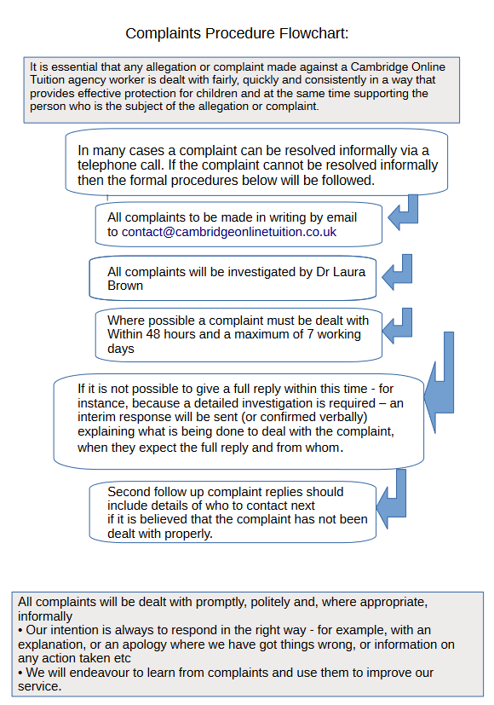

# Policy review

The Compliance Manager will keep this Equal Opportunities and Diversity Policy under annual review and/or if there have been any relevant legislative changes.

15 April 2026